LG-Ericsson Key System

Technical Information

STI-0096

February 10, 2012

Title | iPECS-MG Troubleshooting Guide – Mailbox full in 1.7Cd
System | iPECS-MG
Abstract | This document is guide for Mailbox Full Problem in 1.7Cd

Revision History
Revision | By | History
1.0A | S. J. Park | 2012. 02. 10

Troubleshooting

1. PROBLEM/SYMPTOM
When a user installs new iPECS-MG system (version 1.7Cd), LCD on DKT/LIP phone can be displayed “MAILBOX IS FULL”.

2. CAUSE
DB Protection Option (PGM 223-21) can be set to VM DB when a memory (SRAM) is discharged.
If this is set to “VM DB”, iPECS-MG system does not initialize DB related to Voice Mail.

3. SOLUTION
A user can disable DB Protection Option in Admin Program.
- Set DB Protection Option to OFF in PGM 223-21
- Set the Position of SW1-1 on MPB to OFF
- Set the Position of SW1-2 on MPB to ON
- Reset the system
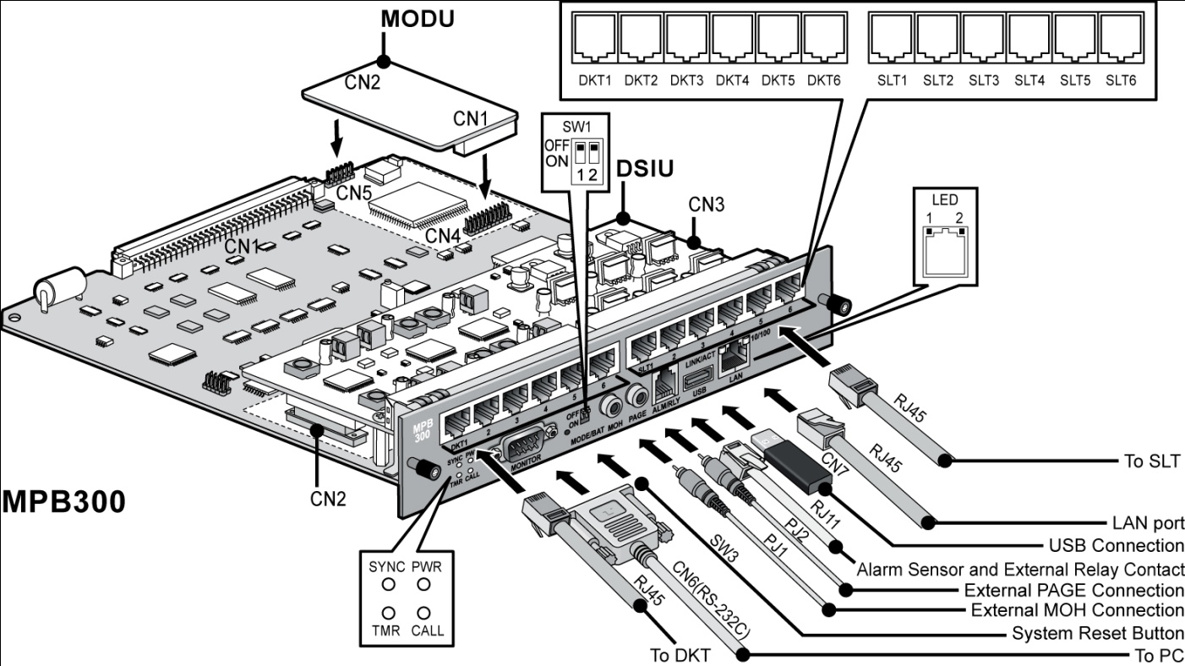

- DB Compatibility
- MPB S/W Upgrade
When MPB S/W is upgraded from under V1.7 to V2.0, all of previous data will be kept.
User can use previous functions. All of features work well.

- MPB S/W Downgrade
In case of Downgrade from V2.0 to under V1.7 S/W, data of DB has to be initialized.

- V1.7 DB file Upload to V2.0 MPB
Saved V1.7 DB file can upload to V2.0 system

- V2.0 DB file Upload to V1.7 MPB

